Elite Patient water jug with blue lid, made in UK
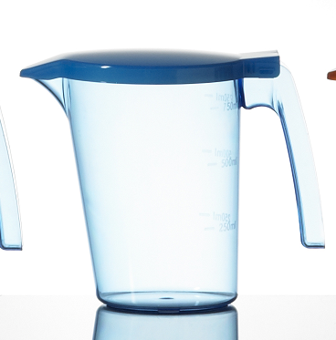
Code LPWJ0001
Item dimensions
Top 110mm
Bottom 80mm
Height 145mm
Weight 150 grams
6 per case
Case dimensions 207 x 207 x 211
Case weight 1.068k
Made from certified food approved material, European and FDA approved.
Graduation lines either side of the handle 250ml, 500ml, 750ml
